22AIE111 OBJECT ORIENTED PROGRAMMING IN JAVA S2 B.Tech CSEAI

Department of Computer Science and Engineering Amrita School of Computing, Amritapuri Campus CASE STUDY
PHASE – 2 (Design) Architectural Modelling (CO2)

Group No : 24
Team Members :
Roll No | Student Name
AM.SC.U4AIE25106 | HARSHA
AM.SC.U4AIE25123 | ABHINAV
AM.SC.U4AIE25143 | RITHESH
AM.SC.U4AIE25111 | SAI KRISHNA

- Problem Title : Automated Courier Management and Tracking System

s

STRUCTURAL DESIGN
- Class diagram
Customer → System Association: Customer interacts with the system to send and track parcels.
Admin → System Control/Management: Admin manages operations and views system records.
CourierAgent → System Association: Courier agent updates delivery status in the system.
System (Central Class) Acts as the core component handling tracking IDs and parcel logS

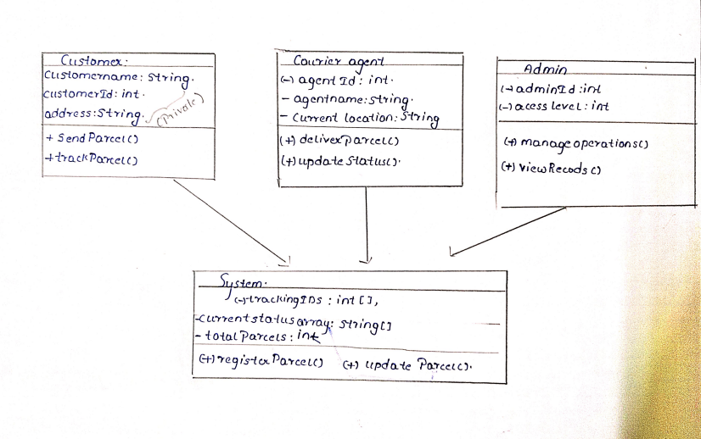

BEHAVIUORAL DESIGN
- Use-case diagram
  - List of actors
1. customer
2. courier agent
3.Admin
  - List of use-cases
1.Send Parcel: Customer initiates the parcel delivery process by
providing necessary details
2.Track Parcel: Customer monitors the real-time tracking status of the
parcel using an ID
3.Deliver Parcel: Courier Agent performs the physical delivery of the
parcel to the destination.
4. Update Status: Courier Agent updates the transit status or location of
the parcel in the system.
5. Manage Operations: Admin oversees system operations and the
management of delivery records.

6. View Records: Admin accesses and reviews historical delivery logs and
system data.
7. Register Parcel: System generates unique tracking IDs and logs new
parcel information.
8.Update System Logs: System stores delivery logs and updates the
tracking status array.

  - Use case diagram (use UML notations)
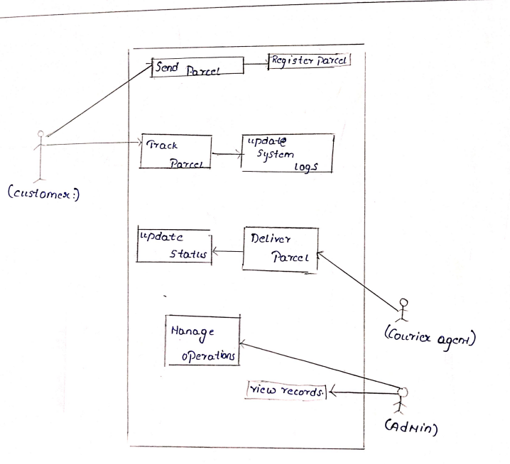

- Sequence diagram (use UML notations)
  - Choose key use cases and draw their sequence diagram. First describe the scenario in few sentences. Then draw the sequence diagram.
CASE : CUSTOMER REQUESTS TO SEND PARCEL
Senior description:The Customer initiates a request to send a parcel by calling sendParcel(). The System then performs an internal check to registerParcel(), which generates a unique ID from the trackingIDs array. Using an alt frame, if the registration is successful, the System returns a trackingID; otherwise, it returns a registration failed message.

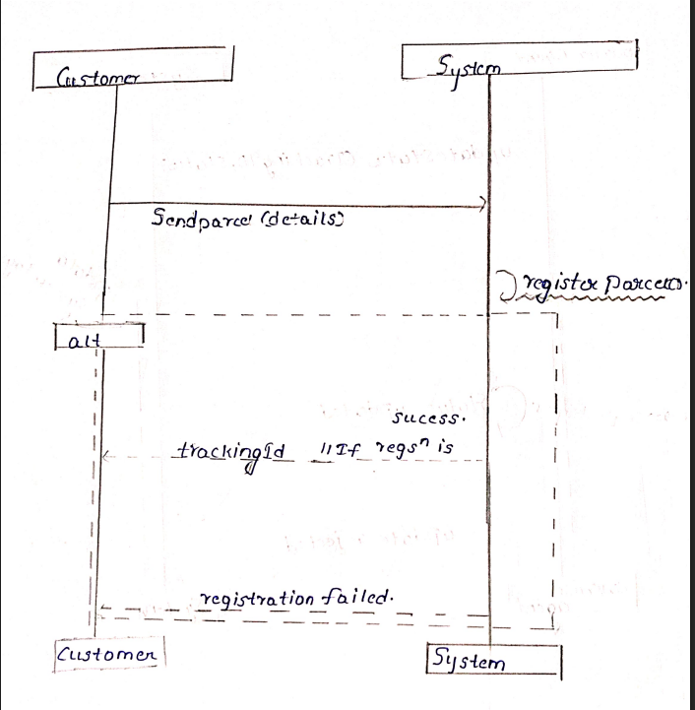

  - Choose key use cases and draw their sequence diagram. First describe the scenario in few sentences. Then draw the sequence diagram.
CASE : The Courier Agent attempts to update the status of a delivery
Scenario Description: The Courier Agent attempts to update the status of a delivery using updateStatus(). The System performs a self-call to updateSystemLogs() to verify and record the entry in the currentstatusarray. Using an alt frame, if the trackingID is valid, the System confirms status updated; if invalid, it returns update rejected.
